For Text Mining assignment

ONE:

1) Extract tweets for any user (try choosing a user who has more tweets)

2) Perform sentimental analysis on the tweets extracted from the above

**Ans :**

**R Code :**

## Text Mining & Sentimental Analysis

########## Twitter Tweets #########

install.packages("twitteR")

library("twitteR")

install.packages("ROAuth")

library("ROAuth")

install.packages("base64enc")

library(base64enc)

install.packages("httpuv")

library(httpuv)

### https://apps.twitter.com/

cred <- OAuthFactory$new(consumerKey='yPv2Z0W5ZTuiMVaZdAytqH8H0',

consumerSecret='E1UIuJczP1JRM0VFb36Z1BScMcJobPGtzqx9XUBU2nTkwJcIo7',

requestURL='https://api.twitter.com/oauth/request_token',

accessURL='https://api.twitter.com/oauth/access_token',

authURL='https://api.twitter.com/oauth/authorize')

#save(cred, file="twitter authentication.Rdata")

#load("twitter authentication.Rdata")

setup_twitter_oauth("yPv2Z0W5ZTuiMVaZdAytqH8H0",

"E1UIuJczP1JRM0VFb36Z1BScMcJobPGtzqx9XUBU2nTkwJcIo7",

"995572125254782976-VRxUhTLGjBeUn53q0CJTeIhPliDXjnS", # Access token

"TPX35FMKDruUOukEaLOZhVE8uxvpBcrZXMnWs8pUwHaW2") # Access token secret key

Tweets <- userTimeline('narendramodi', n = 1000)

TweetsDF <- twListToDF(Tweets)

write.csv(TweetsDF, "Tweets_namo.csv")

getwd()

word_tweets<- searchTwitter('lockdown', n=1000, lang="en", resultType = "recent")

class(word_tweets)

word_tweets[1:20]

fin_txt<-sapply(Tweets, function(x) x$getText())

str(fin_txt)

#https://apps.twitter.com/

library(tm)

fin_corpus<- Corpus(VectorSource(fin_txt))

inspect(fin_corpus[100])

fin_clean<-tm_map(fin_corpus, removePunctuation)

fin_clean<-tm_map(fin_clean, content_transformer(tolower))

fin_clean<-tm_map(fin_clean, removeWords, stopwords("english"))

fin_clean<-tm_map(fin_clean,removeNumbers)

fin_clean<-tm_map(fin_clean, stripWhitespace)

fin_clean<-tm_map(fin_clean, removeWords, c("gameofthrones")) ## clean some words

library(wordcloud)

wordcloud(fin_clean, random.order = F, max.words = 5,colors=rainbow(50))

wordcloud(fin_clean, rot.per=0.5, random.order=TRUE,colors=brewer.pal(8, "Dark2"))

# Term document matrix

# converting unstructured data to structured format using TDM

tdm <- TermDocumentMatrix(fin_clean)

dtm <- t(tdm)

tdm <- as.matrix(tdm)

# Bar plot

w <- rowSums(tdm)

w

w_sub <- subset(w, w >= 20)

w_sub

windows()

barplot(w_sub, las=3, col = rainbow(20))

fin_clean <- tm_map(fin_clean, removeWords, c('apple','air','can','mcds','macbook','product','windows'))

fin_clean <- tm_map(fin_clean, stripWhitespace)

tdm <- TermDocumentMatrix(fin_clean)

tdm <- as.matrix(tdm)

# Word cloud

install.packages("wordcloud")

library(wordcloud)

windows()

wordcloud(words = names(w_sub), freq = w_sub) # wordcloud with only subset of words

w_sub1 <- sort(rowSums(tdm), decreasing = TRUE)

wordcloud(words = names(w_sub1), freq = w_sub1) # all words are considered

windows()

wordcloud(words = names(w_sub1), freq = w_sub1, random.order = F, colors = rainbow(20), scale=c(3,1), rot.per = 0.3)

# lOADING +VE AND -VE dictonaries

pos.words = scan(file.choose(), what="character", comment.char=";") # read-in positive-words.txt

neg.words = scan(file.choose(), what="character", comment.char=";") # read-in negative-words.txt

pos.words = c(pos.words,"wow", "kudos", "hurray") # including our own positive words to the existing list

# Positive wordcloud

pos.matches = match(names(w_sub1), c(pos.words))

pos.matches = !is.na(pos.matches)

freq_pos <- w_sub1[pos.matches]

p_names <- names(freq_pos)

windows()

wordcloud(p_names,freq_pos,scale=c(4,1),colors = rainbow(20))

# Negative wordcloud

neg.matches = match(names(w_sub1), c(neg.words))

neg.matches = !is.na(neg.matches)

freq_neg <- w_sub1[neg.matches]

n_names <- names(freq_neg)

windows()

wordcloud(n_names,freq_neg,scale=c(5,1),colors = brewer.pal(8,"Dark2"))

#### emotion mining ####

install.packages("syuzhet")

library("syuzhet")

library(lubridate,ggplot2)

library(ggplot2)

library(scales)

library(dplyr)

library(reshape2)

x <- get_nrc_sentiment(fin_txt)

head(x,n=5)

fin_txt[4]

get_nrc_sentiment('happy')

get_nrc_sentiment('boring')

get_sentiment('boring',method="afinn")

get_sentiment('happy',method="afinn")

#each sentences by eight

example<-get_sentences(fin_txt)

nrc_data<-get_nrc_sentiment(example)

# Bar plot for emotion mining

windows()

barplot(colSums(nrc_data), las = 1, col = rainbow(10), ylab = 'Count', main = 'Emotion scores')

sentiment_vector<-get_sentiment(example,method="bing")

sentiment_afinn<-get_sentiment(example,method="afinn")

sentiment_nrc<-get_sentiment(example,method="nrc")

sum(sentiment_afinn)

mean(sentiment_afinn)

summary(sentiment_afinn)

windows()

plot(sentiment_vector,type='l',maim='Plot trajectory',xlab='Narative time',ylab='Emotional valence')

abline(h=0,color='red')

plot(

sentiment_vector,

type="h",

main="Example Plot Trajectory",

xlab = "Narrative Time",

ylab= "Emotional Valence"

)

##Shape smoothing and normalization using a Fourier based transformation and low pass filtering is achieved using the get_transformed_values function as shown below.

ft_values <- get_transformed_values(

sentiment_vector,

low_pass_size = 3,

x_reverse_len = 100,

padding_factor = 2,

scale_vals = TRUE,

scale_range = FALSE

)

plot(

ft_values,

type ="l",

main ="Narendra Modi Tweets using Transformed values",

xlab = "Narrative Time",

ylab = "Emotional Valence",

col = "red"

)

#Most Negative and Positive reviews

negative<-example[which.min(sentiment_vector)]

positive<-example[which.max(sentiment_vector)]

################################################

my_example_text <- "I begin this story with a neutral statement.

Basically this is a very silly test.

You are testing the Syuzhet package using short, inane sentences.

I am actually very happy today.

I have finally finished writing this package.

Tomorrow I will be very sad.

I won't have anything left to do.

I might get angry and decide to do something horrible.

I might destroy the entire package and start from scratch.

Then again, I might find it satisfying to have completed my first R package.

Honestly this use of the Fourier transformation is really quite elegant.

You might even say it's beautiful!"

#x-axis represents the passage of time from the beginning to the end of the text, and the y-axis measures the degrees of positive and negative sentiment

s_v <- get_sentences(my_example_text)

s_v_sentiment <- get_sentiment(s_v)

plot(

s_v_sentiment,

type="l",

main="Example Plot Trajectory",

xlab = "Narrative Time",

ylab= "Emotional Valence"

)

**Results :**

> word_tweets<- searchTwitter('lockdown', n=1000, lang="en", resultType = "recent")

> class(word_tweets)

[1] "list"

> word_tweets[1:20]

[[1]]

[1] "Nel29C: RT @JoeDeBobski: #justsayin\nTHE PRESIDENT ANNOUNCED A 21 DAY LOCKDOWN\nSOUTH AFRICA COMPLIED!\nTHE PRESIDENT ANNOUNCED A 14 DAY EXTENSION\nSOU…"

[[2]]

[1] "harles62645324: @narendramodi @mlkhattar Plz bann liquor stores this is getting worse 45days lockdown n all gone in drains."

[[3]]

[1] "reallystella: lmao if y'all gonna continue lockdown until december y'all might as well cancel online classes"

[[4]]

[1] "LockdownNo: Sweden is showing that locking down is a choice. @GOVUK and @scotgov have abandoned human rights at the first sign… https://t.co/CO8nIkiHCz"

[[5]]

[1] "aanand_rajesh: RT @Simi_Garewal: Lockdown opened!!!! https://t.co/wjBQH14RxQ"

[[6]]

[1] "openmin25936589: RT @HenryMakow: \"Dead Zone\" TV show from 2003 mentions corona virus, talks about the Hydroxychloroquine being the cure, and \"lockdown.\"\n\nht…"

[[7]]

[1] "Spanishstar48: RT @realDonaldTrump: Despite reports to the contrary, Sweden is paying heavily for its decision not to lockdown. As of today, 2462 people h…"

[[8]]

[1] "catherinemginn: RT @RBS: Victims of financial abuse may be finding it harder to seek help during the Covid-19 lockdown. To support the #YouAreNotAlone camp…"

[[9]]

[1] "Im_SKSCh: RT @mvmeet: In Mangaluru, engineering student named Sakshath Shetty received 600 threat calls in past few days\n\nHis CRIME is that he starte…"

[[10]]

[1] "AkshayKansara12: @Hasmukhpatelips i am from palghar, maharashtra and i was studying in valsad, gujarat so, due to lockdown condition… https://t.co/0tuteiKwxh"

[[11]]

[1] "randheer_er: RT @Sherni_15: Under the pious guidelines of Saint Dr. @Gurmeetramrahim Singh Ji Insan , During the lockdown , hundreds unit of blood have…"

[[12]]

[1] "IamGeeworld: RT @espeezeal: Caveat: most of the recent flirtations both on the TL and DM Were due to the Lockdown and boredom, I don't owe no one no rel…"

[[13]]

[1] "reshmasiddique1: RT @iamsrk: Extremely grateful to #IforIndia, @Its_Badshah &amp; @cacklerraj for music, lyrics &amp; for working overnight. Thanks Sunil for the ed…"

[[14]]

[1] "VixL: RT @grahambsi: We may be unable to travel to parts of Europe for our holidays once lockdown restrictions are eased, due to the government's…"

[[15]]

[1] "ShanmugarS: RT @ragipsoylu: Flock of sheep invades Turkey’s city of Samsun last night during the coronavirus lockdown \U0001f411 \n\nhttps://t.co/Wmf4pKEGPM"

[[16]]

[1] "gbodi_1: RT @Danny_Walterr: The Covid infection rate increased by over 1,300% in one month we claimed we were on Lockdown.\n\n4th April 2020.\nConfirme…"

[[17]]

[1] "swati_ranjan_: RT @otvnews: Government of India extends relaxation in submission of monthly issues for month of April 2020 which is scheduled in month of…"

[[18]]

[1] "Praveen_9701_: @DeccanHerald I'm missing everything bcz India is a country where every day is a festival with lots of joy… https://t.co/kTeKt3DQNl"

[[19]]

[1] "DaniNishanth1: RT @KollamNanbans: Thalapathy Vijay Makkal Iyakkam, Kollam Nanbans Supplied Rice, Vegetable Kit, Essential Food items to Theatre Staffs of…"

[[20]]

[1] "StaffsSteve: @uk_lollipop Nah wide awake yet again, my body clock is screwed lately, nothing go bed for and nothing wake up for… https://t.co/A7Ks3P9Y8p"

> fin_txt<-sapply(Tweets, function(x) x$getText())

> str(fin_txt)

chr [1:923] "Best wishes to Haryana CM @mlkhattar Ji on his birthday. Manohar Lal Ji has been working assiduously for Haryan"| __truncated__ ...

> fin_corpus<- Corpus(VectorSource(fin_txt))

> inspect(fin_corpus[100])

<<SimpleCorpus>>

Metadata: corpus specific: 1, document level (indexed): 0

Content: documents: 1

[1] Proud of citizens like him! They are adding so much might in the battle against COVID-19. https://t.co/nPCAsn9mUQ

> tdm <- TermDocumentMatrix(fin_clean)

> dtm <- t(tdm)

> tdm <- as.matrix(tdm)

> # Bar plot

> w <- rowSums(tdm)

> w

assiduously best birthday haryana haryana’s…

1 15 11 3 1

httpstcoambmdbtmuv lal manohar mlkhattar wishes

1 2 1 1 18

working conferencing held httpstcoyraibctpkq nam

26 5 5 1 1

spoke summit via video armed

13 3 7 16 3

bravely covid fighting forces forefront

1 103 6 5 6

gesture great httpstcocqtqqkxma saluting colleague

29 22 1 2 2

good health life long mundaarjun

32 10 20 9 1

praying shri ashokgehlot blessed greetings

3 17 1 4 23

healthy pray rajasthan courageous handwara

11 4 1 2 1

httpstcogbdldpimyc martyred ne… personnel sacrifice

1 2 1 3 1

security soldiers tributes valour will

6 1 10 4 97

aris… businesses central difficulties ensuring

1 2 4 1 9

focused government helping httpstcorrqtgihna overcome

4 12 9 1 8

welfare workers bo… discuss financial

5 2 2 7 1

give httpstcolsmqnbxo including meeting reforms

6 1 7 16 5

related structural subjects world chaired

5 1 4 18 5

development economic httpstcovtgcqaismx msme pivotal

9 5 1 3 1

plays role sector strengthening …

1 14 11 4 114

actively brand developing fpos httpstcotvcjalty

1 1 1 1 1

india sector… towards can cards

107 1 27 31 1

credit discussed enam even… existing

2 17 1 1 1

httpstcoxdavkhavju kisan made measures pmkisan

1 2 13 3 2

ranging ways agriculture areas aspects

1 14 4 1 10

httpstcockzndkkr marke… priority reform relating

1 1 2 1 6

review deeprooted friend hist… httpstcorqruqh

3 3 16 1 1

issues neighbours pandemic prayutofficial always

6 2 14 1 13

disasters even httpstcoeiwrbcr kept nation

1 8 1 1 22

n… people safe times announcements

3 54 2 10 3

chief defence du… fight httpstcoggwgimozx

11 5 1 36 1

staff strong today waged welcome

4 9 35 1 9

discussions education edu… httpstcosqfllsevdr indepth

5 3 1 1 2

deliberations earlier hardworking httpstcobrmmkryi labour

1 7 5 1 2

proud enhancing focus httpstcocxbdxkgn imp…

18 1 3 1 2

power resilience sustainability aviation httpstcoxhqccgqhme

8 1 1 1 1

includes ma… reviewed close early

2 1 3 2 2

httpstcojjqwcfl mishustin recovery russia russian

1 1 3 1 1

stand httpstcowskrzmjbs выздоровления гну желаю

3 1 1 1 1

здоровья искренне крепкого мишустину плечом

1 1 1 1 1

плеч… премьерминистру россии скорейшего httpstcopthdepbtzo

1 1 1 1 1

ખૂબ ગુજરાતની ગુજરાતીઓએ ઘણાં… છે

2 2 1 1 2

જનતાને જાણીતી દિવસની પુરુષાર્થ પ્રજા

1 1 1 1 1

માટે રાજ્યના શુભેચ્છાઓ સ્થાપના httpstcodmfmxsq

1 1 1 1 1

जडणघडणीतील दिनानिमित्त देशाच्या बंधू भगिनींना

1 1 1 1 1

भ… महाराष्ट्र महाराष्ट्राच्या माझ्या राज्यातल्या

1 2 1 1 1

शुभेच्छा aerospace boost httpstcoodeepkiy india’s

2 2 4 1 33

selfreliant… courageously covid… fill happiness

1 1 12 3 6

heart httpstcozxadhqodvk like moments spirit

2 1 16 4 15

abundant coal ensure extensive httpstcohetgjygnt

1 1 12 15 1

mines sectors supply… domestic highlevel

1 4 1 1 1

httpstcodlkaldnulw international investment relating… aung

1 7 1 1 1

counsellor daw discussion evolving httpstcocthtnvo

1 1 8 2 1

kyi san scenario state suu

1 1 1 3 1

endearing httpstcoqmsqdz kapoor livelythis multifaceted

1 1 1 1 3

powerhouse recall… rishi talent httpstcoygympafyf

1 1 1 3 1

अन्नदाताओं अपने और करने… का

1 11 59 1 45

किसान के को गर्व देश

2 134 85 1 21

पर पूरे पेट बहनों भरने

27 3 1 2 1

भाइयों भारत वाले सुनिश्चित हितों

2 10 4 2 1

है। battling every fearlessly httpstcokzunyist

44 6 10 2 1

musical person tribute amp bangladesh

1 3 2 7 2

greet hasina holy httpstcozwwggp month

1 3 2 1 2

ramzan sheikh cinema demise httpstcojwhjdbjg

3 4 1 1 1

irrfan khan’s loss performa… remembered

1 1 1 1 6

theatre versatile canada citizens diffic…

1 3 1 15 1

exchange httpstcoxtkzijs indian justintrudeau looking

2 1 10 1 5

thanked warm cnnnews contribute covered

3 4 2 5 2

different effort excellent fig… httpstcovqujzzlm

10 12 11 1 1

wonderfully compreshensive httpstcozjhncrcjoy jokowi maritime

3 1 1 1 1

president str… affectionate creative httpstcoxqtlibflgw

27 3 1 3 1

immense please source strengt… swetha

7 6 1 1 1

thank valuable compass… delhipolice exceptional

45 9 1 1 2

gurudwaras httpstcoqprkydknt serving work aspects…

1 1 4 23 1

cms containing continued httpstcoivyvwjkqy interaction

2 1 1 1 9

strategy well basava basavanna conference

2 22 1 1 8

global httpstcodvhaxbbmo ideals jayant… lord

8 1 1 1 5

noble rich shared thoughts httpstcofrkcmllr

3 7 9 7 1

आदर्श की जयंती तक… तप

2 76 10 1 1

देशवासियों परशुराम प्रतीक बधाई। बल

27 2 3 5 3

भगवान युगोंयुगों समस्त साहस हार्दिक

1 1 3 4 9

httpstcozgarpxoez इन एक खुलता जीवन

1 3 17 1 6

तो देखें द्वार नया ने…

6 1 1 3 2

पीछे प्रकृति भाव विकृति शब्दों

2 3 3 1 1

संस्कृति समझने cherishes epidemic… frontline

3 1 2 1 1

httpstcorjqxeokw lives protecting saving httpstcogsgirni

1 11 1 3 1

immunity improve let’s mannkibaat popularise

2 3 7 16 2

systems traditional battle httpstcontcqofpsy midst

1 3 16 1 1

place p… right take taking

5 5 9 12 14

year awareness end homemade httpstcokukkgtfkw

6 6 1 1 1

masks need now options realisation

1 14 7 1 1

sp… wear crore driven httpstcoltfdepsv

1 1 4 1 1

occasion risen httpstcohignjdbfs अक्षय अपनी

10 3 1 1 2

आप तृतीया धरती प्रयासों बनाने…

9 1 1 1 1

मिलकर शुभकामनाएं।आइए सबको से हम

1 1 2 51 7

‘अक्षय’ ‘अविनाशी’ april httpstcotkteugjck getting

1 1 2 1 1

httpstcobwpkfixoyc inputs insightful months several

1 2 3 2 5

tomorrow tune commendable efforts httpstcoajscmtxyd

13 5 4 17 1

important assisting dur… httpstcotenptxwdx indiapostoffice

18 1 1 1 1

kudos network postmen stupendous abundanc…

7 1 1 1 1

bring everyone’s httpstcobisunatd may mubarak

8 3 1 16 4

prosperity safety wellbeing httpstcosucwamjsup आज

3 3 2 1 10

आर्थिक उनकी उन्हें ग्रामीण दिलाने

3 6 4 1 2

बनाने मालिकाना रूप लिए लोगों

1 2 2 31 8

संपत्ति सरकार सशक्त हक httpstcojodelqdue

1 9 1 2 1

उनके एकीकृत कार्यों जानकारियों देखरेख

2 1 1 1 1

पंचायतों पर… प्रभावी प्लेटफॉर्म विकास

1 1 1 1 7

संचालन सभी drpramodpsawant goa service

1 21 1 1 7

httpstcoqtstqo panchayat sarpanchs strategies today’s

1 1 3 1 11

across country divas httpstcoirkvxlkn interacting

9 5 1 1 6

panchayati raj videoconferencing help httpstcozdlmmrqax

2 2 2 16 1

steps taken vulnerable care exchanged

9 3 2 4 3

ext… httpstcodqfchy leehsienloong support views

1 1 1 17 6

egramswaraj httpstcofndatin अप्रैल इस इसके

2 1 2 22 3

ऐप किया कॉन्फ्रेंसिंग जाएगा। दौरान

1 9 2 2 1

पोर्टल मोबाइल लॉन्च वीडियो साथ

1 1 1 3 13

स्वामि… ही httpstcojkpqkcdaa अवसर के…

1 12 1 6 4

जरिए दिवस देशभर पंचायती मैं

2 9 4 1 8

राज राष्ट्रीय शुक्रवार सरपंचों app

1 2 1 1 2

httpstcoilvqkvt launched mobile portal sch…

1 2 1 1 1

swamitva acros… day friday httpstcoxckanrxaik

1 1 28 1 1

marked national aarogya ajaydevgn download

2 9 6 1 2

family f… httpstcoagksfniw protects said

11 3 1 2 8

setu strengthen httpstcooebzjxjow અને આંખોમાં

7 7 1 1 1

આજ એ જે ઢાળી તમે

1 1 1 1 1

દિને પહેલા પૃથ્વી પૃથ્વીની ફરી

1 1 1 1 1

ભવ્યતા મારી મા… મેં રમ્યતા

1 1 1 1 1

વર્ષો શબ્દોમાં હતી also bonds

1 1 1 26 1

httpstcoxbjjsuee indianepal relationship solidari… special

1 1 1 1 13

stands approaches httpstcogtxovicny ireland ireland’s

3 1 1 1 1

leovaradkar many… share similar amendment

1 1 6 2 1

commitment diseases epidemic healthcare httpstcosvijxoeaj

6 2 1 3 1

manifests ordinance protect wor… abundance

1 1 4 1 1

compassion… earth express gratitude httpstcoztbfbjzau

1 1 3 6 1

mother planet httpstcojftdxjvgh stars arjunbhatigolf।

2 7 1 2 1

httpstcorydejntsrs अनमोल आपका आपकी क…

1 1 5 1 3

घड़ी प्रेरित भावनाएं मुश्किल में

4 4 1 1 64

यह सेवा हैं artistes gujarati

13 5 9 1 2

httpstcogsduiabw talented wonderful administrative civil

1 4 11 1 3

emphasis… envisioned framework httpstcosmupyjjmf patel

1 1 1 1 1

sardar services appreciate convey effo…

1 2 5 1 1

families httpstcoulcxlbyy servants afghanistan based

1 1 1 2 2

culture friendship geography history httpstcornehblzt

6 3 1 5 1

ties bond common enemy httpstcoywddgsme

1 1 5 1 1

maldives resolve strengthens together wil…

6 6 2 23 2

challenges ibusolih phone poses coopera…

6 3 6 1 1

httpstcoopiacebdb kazakhstan partners strategic tokayev

1 1 1 1 1

tokayevkz words httpstconpwzqgiu करते करना

1 10 1 2 1

चलें डिस्टेंसिंग दुकानें पालन भविष्य

1 1 1 3 1

भी योगदान… संकट सोशल हमें

16 1 4 1 7

हुए httpstcoqzyjszdu इनके इ… छोटेछोटे

3 1 1 1 1

दिया दुकानदारों ने पूरी बनाए

4 1 16 3 1

महत्वपूर्ण योगदान रखने व्यवस्था समाज

4 3 1 1 7

सामाजिक सुचारू httpstcopprghmg अनेक इसमें

3 1 1 1 1

कर देशवासी पा भूमिका रहे

6 1 1 2 10

लॉकडाउन वर्गों सकारात्मक battles energetic

2 1 3 2 1

healthier httpstcoczzhzzke innovative pr… show

12 1 4 4 2

way youth al… among essential

10 13 2 8 7

httpstcomiluyicna keep part precautions small

1 14 10 11 7

tasks teammaskforce certainly c… defeat

2 1 3 9 9

httpstcohsbqrqkzqa panic proper clock energy

1 8 4 5 2

httpstcosxnjn met needs round committed

1 6 3 5 4

dynamic httpstconsjqjppf medium assistance httpstcoxjqtjfvzm

3 1 1 1 1

possible httpstcokgwptua humanity surely continuously

9 1 2 3 1

crucial hour httpstcolnryjjpyjz railways team

2 3 1 2 6

’ve abdel alsisiofficial eg… elsisi

4 1 1 1 1

fattah httpstcozjavmv situation ably africa

1 1 12 1 1

african afric… coordinating httpstcodfhifvqae longstanding

1 1 1 1 1

south union assured challenge cyrilramaphosa

2 1 1 3 1

httpstcofcrewguzy s… enhance greatly httpstcocivdfpjf

1 6 1 3 1

liquidity rbi supply danny faure

1 2 2 1 1

grateful httpstcoxjuewyphp kind member ocean

5 1 6 1 2

seychelles valued httpstcoijmpkifgss lotay majesty…

1 3 1 2 1

pmbhutan region tshering agreed httpstcotdejapyf

3 1 2 7 1

jordan kingabdullahii majesty posed wou…

1 1 2 1 1

coronavirus defeating gupta httpstcojzgulit loo…

19 4 3 1 1

raising saibaa saisha youngsters d…

2 1 1 4 2

httpstcokuradxcbf organisations play popularising step

1 7 3 1 5

vital adding httpstconpcasnmuq might much

3 4 1 2 4

giving httpstcogedcybaroz kabaddi know players

2 1 1 8 2

telling thing trust two wi…

2 2 2 2 2

httpstconzziw उसमें कोरोना खेलखेल जो

1 1 27 1 8

बचने बच्चों बड़ी बता महामारी

1 1 4 1 5

सीख httpstcofmhhhi अद्भुत कार्य किए

1 1 1 1 4

गाड़ोलिया जा द्वारा नेक परिस्थितियों

1 5 3 1 1

प्रेरक प्रेरित… भारतवासी मिसाल ये

2 1 1 2 16

विषम हर chess harikrishn… httpstcofqsxkmaey

1 10 2 1 2

pentala viditchess vishytheking compassionate extremely

1 1 1 3 8

httpstcouhfeqy nseindia httpstcohjimnnqh httpstcouuyslp pleased

1 1 1 1 3

body call httpstcoscpwdvp add happy

1 6 1 4 20

httpstcoippchakj ’ll children httpstcobpikjku played

1 2 6 1 4

proactive remember httpstcobpikjk httpstcozqzmi \U0001f44c\U0001f3fd

2 9 1 1 1

abbas httpstcowfodktigb mahmoud palestinian provide

1 1 1 1 2

sup… httpstcolkttihxsqu करने निष्ठा प्राप्त

1 1 12 1 1

बातों मांग मार्ग रहा विजय

1 1 3 8 4

सप्तपदी​ सात हूं। httpstcorkwwvqrozg manner

1 1 4 1 1

menace walks companies httpstcoqcvuugyivi leading

9 4 1 1 9

rising samsungindia begin httpstcobtvfgs new

4 1 1 1 13

downloads effective httpstcoaywxoyvqi address httpstcosvpbrn

1 3 1 5 1

httpstcoqgzqbw অসমীয়া অসমৰ আটাইকে আন্তৰিক

1 1 1 1 1

আপোনালোক আৰু এই ওলগ কৰিছোঁ।

1 2 2 1 1

জনজীৱনৰ… জ্ঞাপন তথা নৱবৰ্ষৰ বিহু

1 1 1 1 1

[ reached getOption("max.print") -- omitted 4307 entries ]

> w_sub <- subset(w, w >= 20)

> w_sub

working covid gesture great good life

26 103 29 22 32 20

greetings will … india towards can

23 97 114 107 27 31

nation people fight today india’s और

22 54 36 35 33 59

का के को देश पर है।

45 134 85 21 27 44

president thank work well की देशवासियों

27 45 23 22 76 27

से लिए सभी इस day also

51 31 21 22 28 26

में together कोरोना happy indiafightscorona watch

64 23 27 20 43 22

many contribution है pmminute young

24 21 35 23 29

> x <- get_nrc_sentiment(fin_txt)

> head(x,n=5)

anger anticipation disgust fear joy sadness surprise trust negative positive

1 0 1 0 0 1 0 1 0 0 2

2 0 0 0 0 0 0 0 0 1 0

3 2 0 0 1 0 0 0 0 2 1

4 0 3 0 0 2 0 2 1 0 2

5 0 3 0 1 3 0 2 1 0 4

> fin_txt[4]

[1] "Birthday wishes to my colleague Shri @MundaArjun Ji. Praying for his good health and long life."

> get_nrc_sentiment('happy')

anger anticipation disgust fear joy sadness surprise trust negative positive

1 0 1 0 0 1 0 0 1 0 1

> get_nrc_sentiment('boring')

anger anticipation disgust fear joy sadness surprise trust negative positive

1 0 0 0 0 0 0 0 0 1 0

> get_sentiment('boring',method="afinn")

[1] -3

> get_sentiment('happy',method="afinn")

[1] 3

> sum(sentiment_afinn)

[1] 1587

> mean(sentiment_afinn)

[1] 0.8860972

> summary(sentiment_afinn)

Min. 1st Qu. Median Mean 3rd Qu. Max.

-6.0000 0.0000 0.0000 0.8861 2.0000 10.0000

**Plots :**

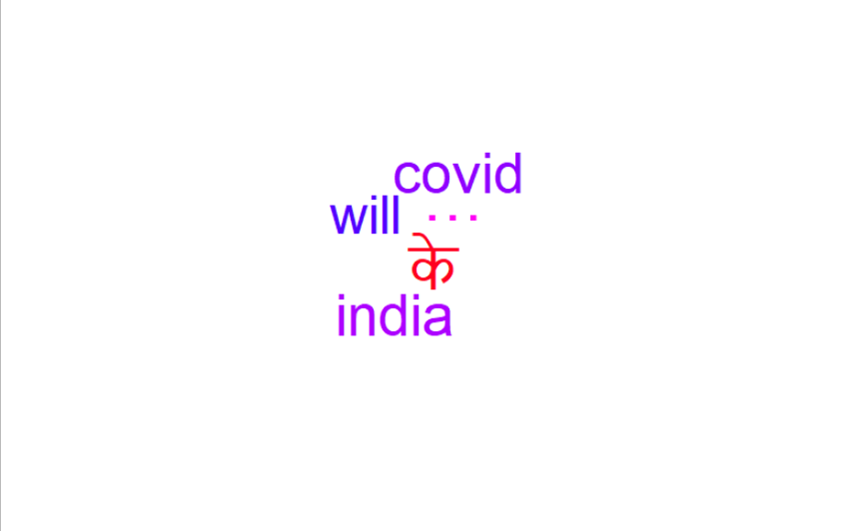

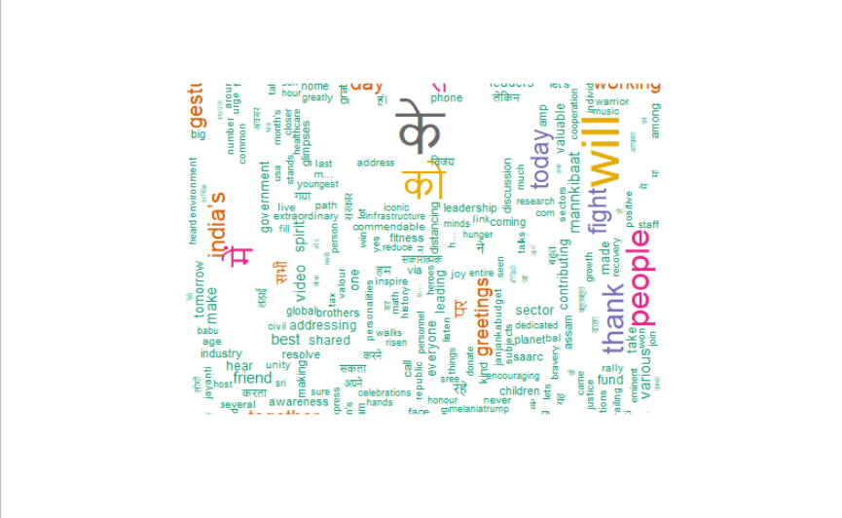

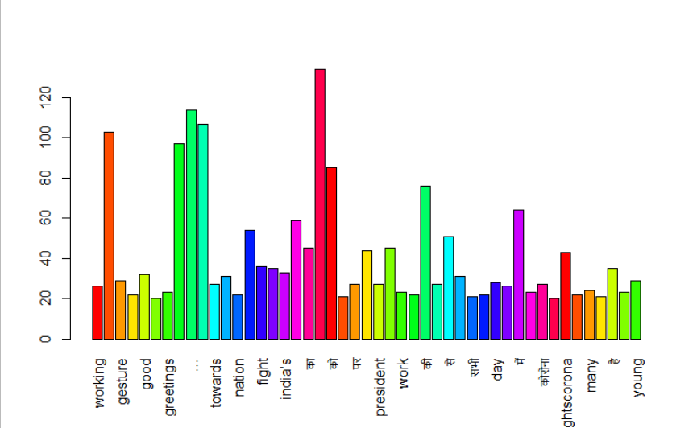

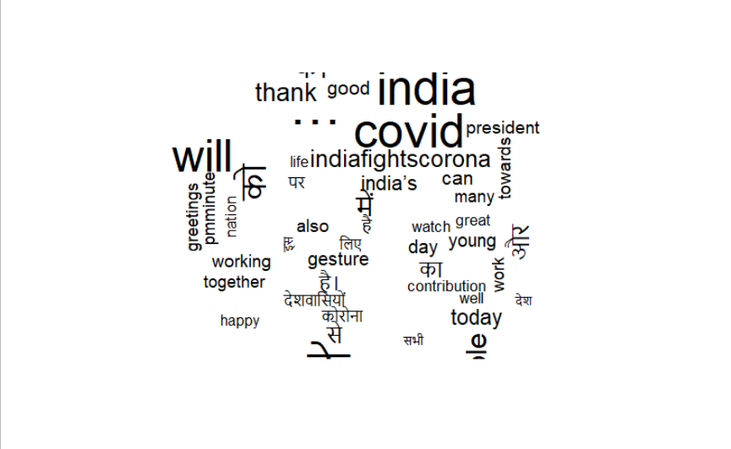

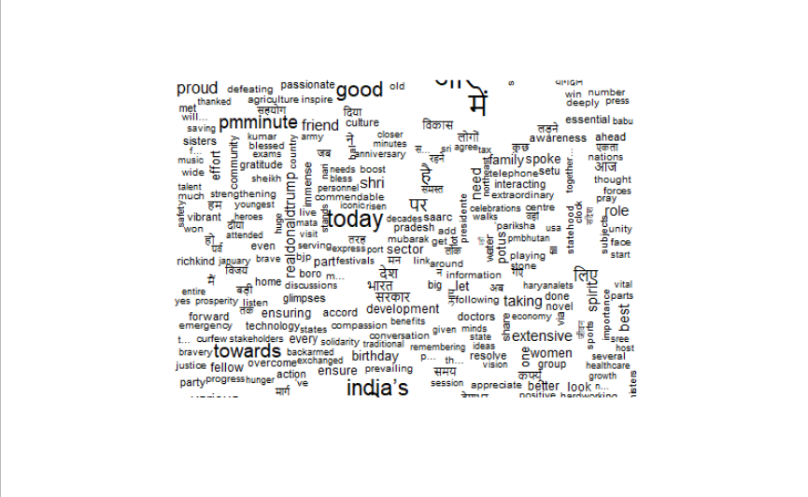

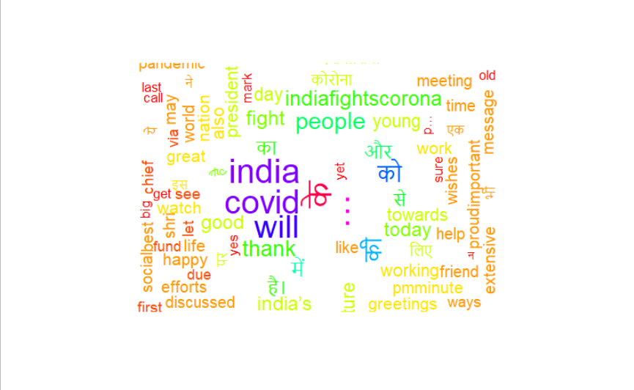

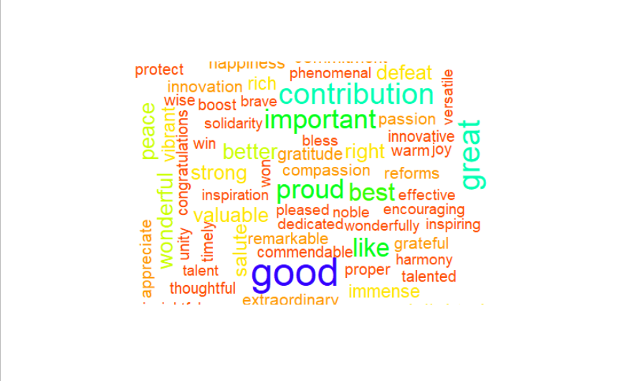

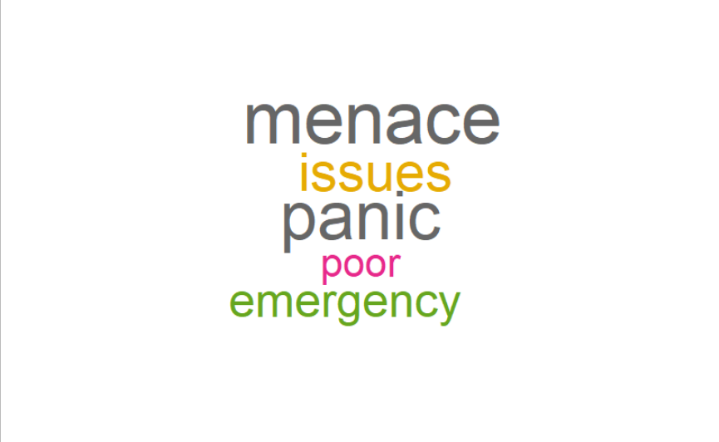

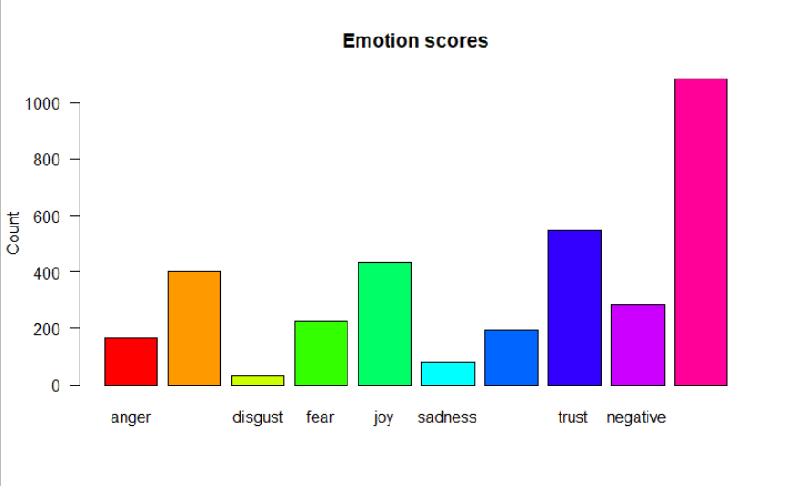

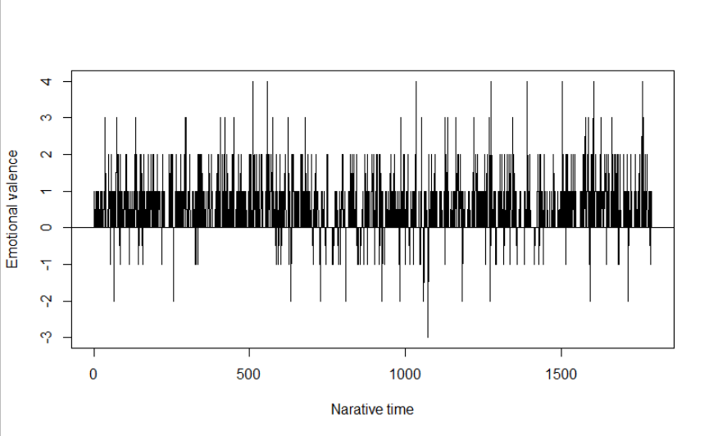

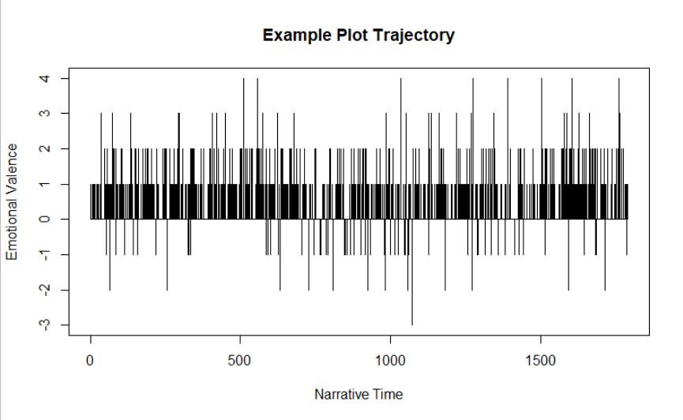

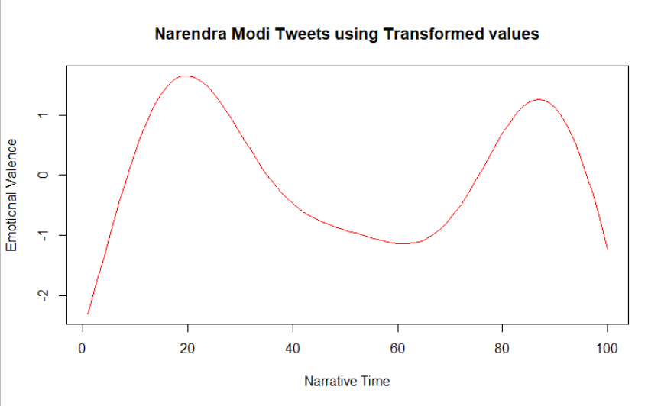

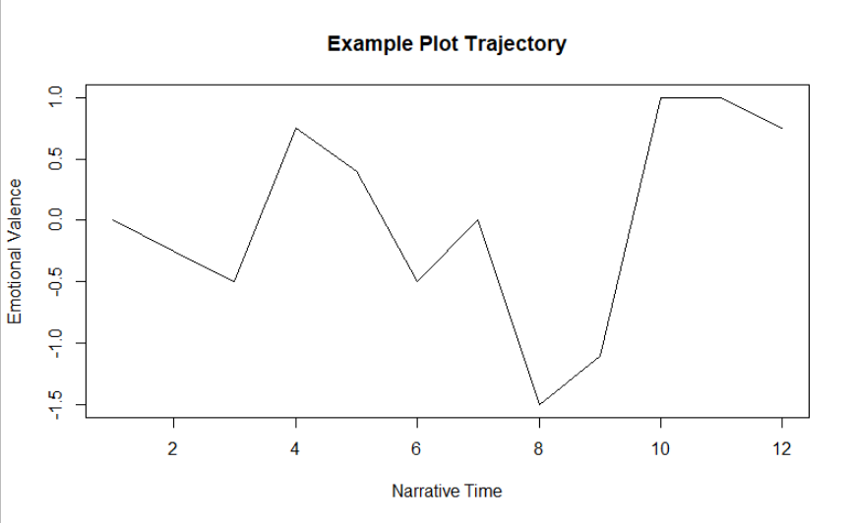

**Inference :**

The mean sentiment value is of 0.88. Hence, we can infer that the tweets are mostly on positive side.